

Osborne Co-operative Academy Trust is a multi-academy trust (MAT) incorporated around the principles and values of the international co-operative movement. These are Equality, Equity, Democracy, Self-help, Self-Responsibility and Solidarity, along with the ethical values of openness, honesty, social responsibility and caring for others. These values and principles underpin all our actions.

# Legislation and guidance

This policy reflects the requirements for academies to provide a broad and balanced curriculum as per the [Academies Act 2010](http://www.legislation.gov.uk/ukpga/2010/32/section/1A), and the [National Curriculum programmes of study](https://www.gov.uk/government/collections/national-curriculum) which we have chosen to follow.

It also reflects requirements for inclusion and equality as set out in the [Special Educational Needs and Disability Code of Practice 2014](https://www.gov.uk/government/publications/send-code-of-practice-0-to-25) and [Equality Act 2010](http://www.legislation.gov.uk/ukpga/2010/15/part/6/chapter/1), and refers to curriculum-related expectations of governing boards set out in the Department for Education’s [Governance Handbook](https://www.gov.uk/government/publications/governance-handbook).

This policy complies with our funding agreement and articles of association.

In addition, this policy acknowledges the requirements for promoting the learning and development of children set out in the [Early Years Foundation Stage (EYFS) statutory framework](https://www.gov.uk/government/publications/early-years-foundation-stage-framework--2).

# 

**2. Curriculum Intent**

At Thameside Primary School, the curriculum has been designed to;

* Provide a broad and balanced education for all pupils that’s coherently planned and sequenced towards cumulatively sufficient knowledge for skills and future learning and employment
* Enable pupils to develop knowledge, understand concepts and acquire skills, and be able to choose and apply these in relevant situations
* Support pupils’ spiritual, moral, social and cultural development
* Support pupils’ physical development and responsibility for their own health, and enable them to be active
* Promote a positive attitude towards learning
* Ensure equal access to learning for all pupils, with high expectations for every pupil and appropriate levels of challenge and support
* Have a high academic/vocational/technical ambition for all pupils
* Equip pupils with the knowledge and cultural capital they need to succeed in life
* Provide first hand learning experiences
* Allow the children to develop interpersonal skills
* Build resilience
* Become creative, critical thinkers
* Provide exciting and engaging learning opportunities, which are challenging and knowledge-rich
* Utilise the school’s locality and supportive and diverse community, using the rich opportunities and resources that are on our doorstep.

The curriculum is underpinned by the Co-Operative values of;

* Self-Help
* Self-Responsibility
* Democracy
* Equality
* Equity
* Solidarity

These are used to encourage positive attitudes to learning which reflect the values and skills needed to promote responsibility for learning and future success. The broad and balanced curriculum is designed to enable all children to become confident, enquiring and knowledge-thirsty learners, who will be prepared for each new stage of their education. Our curriculum provides children with a range of experiences to ignite curiosity, broaden cultural understanding and recognise their place individually, within the community and the wider world.

The Thameside curriculum has four structural tiers. Each tier builds on the previous one to create interconnected layers. These interconnected layers provide a robust framework that ensures connectivity across the curriculum. The tiers of the curriculum structure are set out in the diagram below and are explained in the following paragraphs.

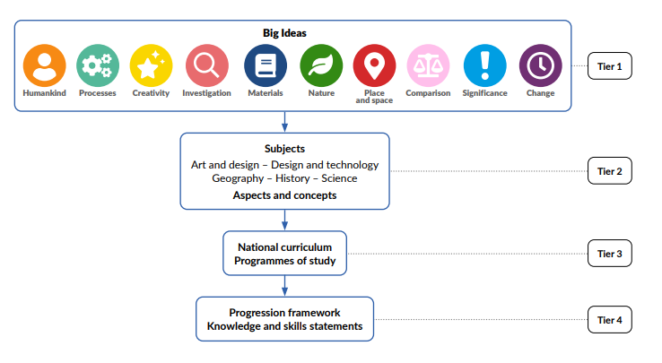

**Tier 1: Big Ideas (global aims)** The curriculum is led by 10 central Big Ideas. These Big Ideas are the overarching aims of the curriculum. They were conceived by careful analysis of the national curriculum subjects, drawing out common themes, which then, through a period of refinement, became our Big Ideas. These Big Ideas and their intentions are set out below.

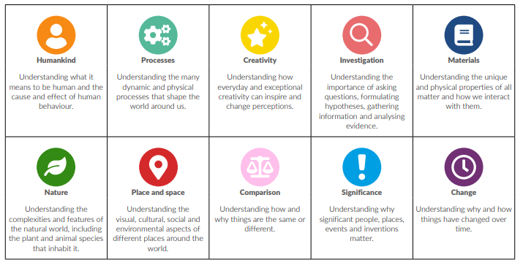

**Tier 2: Subjects (aspects and concepts**) In the Thameside curriculum, we use the terms ‘aspects’ and ‘concepts’. An aspect is a particular part or feature of a subject, and a concept is an abstract idea within a subject. In the curriculum structure, each Big Idea is directly connected to the curriculum subjects, which have the relevant aspects or concepts through which the Big Idea can be delivered. For example, in geography, the Big Idea of Humankind is connected to and delivered through the geographical aspects of Settlements and land use and Human features and landmarks. In history, the Big Idea of Humankind is connected to and delivered through the historical aspects and concepts of Everyday life, Hierarchy and power, and Civilisations.

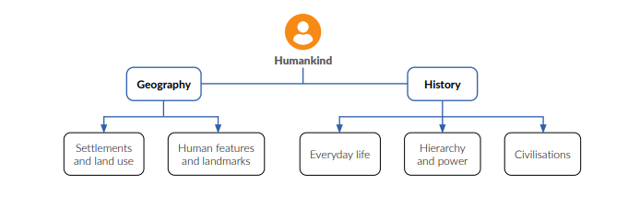

The diagram below shows how the Big Idea of Humankind is linked to each subject via its aspects and concepts.

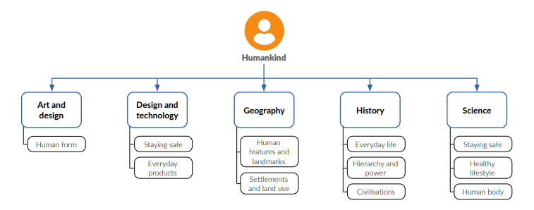

**Tier 3: Programmes of study (national curriculum coverage)** To ensure coverage of the national curriculum, each subject aspect or concept is then matched to the relevant programmes of study. Across the curriculum, there is full coverage of the programmes of study for art and design, design and technology, geography, history and science. The diagram below shows an example of how Tier 2 leads into Tier 3.

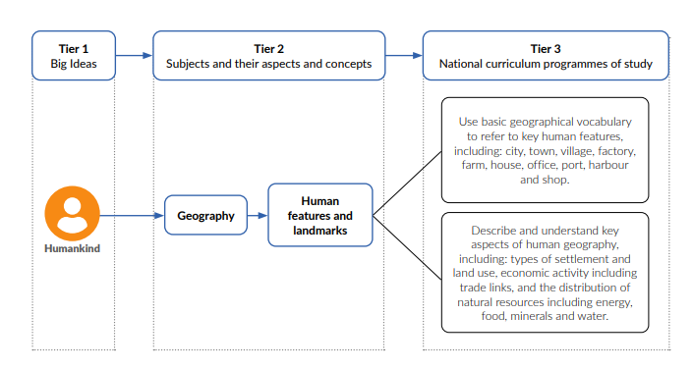

**Tier 4: Progression framework (knowledge and skills statements)** In Tier 4, programmes of study, aspects and concepts are broken down into smaller component parts or ‘chunks’ to form a cohesive progression framework. The progression framework runs from Nursery to Year 6 and includes knowledge and skills that children need to know and be able to do in order to make progress through the curriculum.

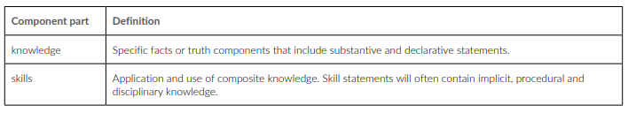

The diagram below shows how a programme of study is broken down further into knowledge and skills statements for the aspect of Human features and landmarks in geography.

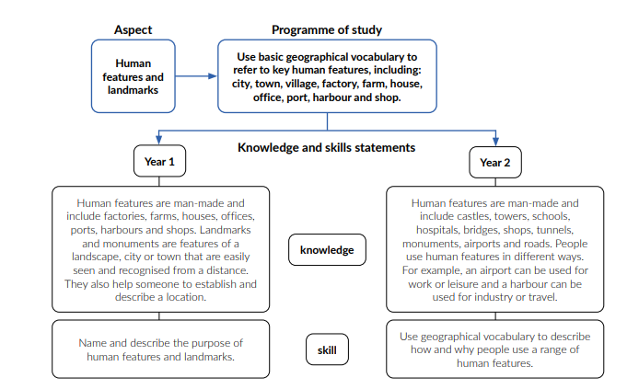

1. **Curriculum Implementation**

The structure of the Thameside curriculum provides a robust framework on which to build deliverable content. The content is delivered through a range of broad and balanced, knowledge-rich projects. The knowledge and skills statements provide the foundation for, and are directly linked to, the sequential lesson plans and resources within each project. Each project follows the pedagogy of Engage, Develop, Innovate and Express. The long-term plans (see Appendix 1) set out the projects for each year group and term. Projects are organised to maximise meaningful links between subjects, aspects and concepts.

Each topic starts with a memorable experience that is used to engage learners and build an interest right from the onset. The implementation is adapted to specific learning needs in order to provide support and challenge, ensuring an inclusive curriculum that meets the needs of all our pupils. Each topic within the curriculum has been carefully chosen to reflect the diversity of pupils within our school and in our local area.

Early Years’ education follows the framework for EYFS and we use the curriculum as a basis for topics which support this learning. Literacy and mathematics are taught as discrete subjects but will often link to the themes chosen for each unit.

Activities are engaging and practical, building on individual starting points and key interests within the year group. Teaching is delivered through a balance of direct teaching and carefully planned, child initiated activities. Timely interventions from all adults are given to move individuals forward.

In KS1 & 2, subject-specific projects cover art and design, design and technology, geography, history and science. Maths is delivered through projects from the White Rose Maths scheme, and English is developed through the use of The Write Stuff and our own reading curriculum. Other subjects are taught using schemes or resources such as the Dimensions curriculum for PSHE and NCCE for computing. French. Maths, reading, writing, RE and PE are taught as discrete blocks. Our English lessons are taught through high quality texts that are often linked to the curriculum topic or theme.

We offer a wide range of extra-curricular after-school clubs which complement and further develop children’s achievements in our curriculum; including football, dance, athletics, reading, colouring, coding and choir amongst many others. We have extremely high aspirations for all of our children and skilfully use targeted support for our children who find learning and social situations a challenge at times. Clear and concise challenges are set across the curriculum for children who are ready for the next step in their learning.

**English**

We aim to deliver an exciting English curriculum which is based around high quality texts that cover a variety of genres as well as fiction, non-fiction and poetry. We plan lessons which link reading and writing which then provides pupils with a rich and varied vocabulary for use in their work across the curriculum. We use the Little Wandle phonics and reading programme to teach reading. The Write Stuff is a step-by-step framework for strengthening the teaching of writing based on the fundamental principles.

**Maths**

We aim to help children to develop as confident mathematicians with fluent arithmetic skills that can be applied to problem solving and reasoning about mathematical concepts. We follow the White Rose Maths Curriculum and teach maths mainly through discrete learning units. There is a strong focus on consolidating fluency in arithmetic skills as well as reasoning to ensure the children can apply knowledge, skills and understanding in a range of contexts. The process of teaching maths begins by exploring the concept by using concrete materials. This is then followed by transferring this knowledge into pictorial representations of a concept. A deeper understanding is developed with opportunities for the children to explain and justify their mathematical reasoning. Finally, this knowledge is transferred and applied into abstract contexts including real life situations.

**Science**

Science programmes of study in the national curriculum are assigned to year groups. However, this is not compulsory and they must be covered before the end of the phase. Physics is not formally introduced until Key Stage 2. However, in Key Stage 1, children have opportunities to explore natural phenomena, such as shadows.

In the Thameside curriculum, the names of the science projects are matched to the national curriculum aspects, for example, Living things and their habitats and Earth and space. However, in Key Stage 1, the aspect of Animals, including humans has been separated so that children study humans before expanding to explore animals. The science projects are sequenced to develop both children’s substantive and declarative knowledge, and if possible, make meaningful links to other projects. For example, in Year 3, the projects Plant Nutrition and Reproduction and Light and Shadows are taught alongside the design and technology project Greenhouse and the art and design project Beautiful Botanicals. These links allow for children to embed their substantive knowledge in new and often real-life contexts. The sequencing of projects ensures that children have the substantive knowledge and vocabulary to comprehend subsequent projects fully. Each project’s place in the year has also been carefully considered. For example, projects that involve growing plants or observing animals are positioned at a suitable time of year to give children the best possible opportunity to make first-hand observations. Within all the science projects, disciplinary knowledge is embedded within substantive content.

**History**

The history projects are well sequenced to provide a coherent subject scheme that develops children’s historical knowledge, skills and subject disciplines. Key aspects and concepts, such as chronology, cause and effect, similarity and difference, significance and hierarchy, are revisited throughout all projects and are developed over time. All projects also develop historical skills based on evidence and historical enquiry.

The choice of historical periods follows the guidance set out in the national curriculum, with specific details relating to significant events and individuals chosen to present a rich and diverse account of British and world history.

Where there are opportunities for making meaningful connections with other projects, history projects are sequenced accordingly. For example, the project Dynamic Dynasties is taught alongside the art and design project Taotie to give children a better all-round understanding of ancient Chinese arts and culture. All history projects are taught in the autumn and summer terms, with opportunities for teachers to revisit historical concepts in some of the spring term geography projects.

**Geography**

The geography projects are well sequenced to provide a coherent subject scheme that develops children’s geographical knowledge, skills and subject disciplines.

Geographical locations are not specified in the national curriculum, so they have been chosen to provide a broad and diverse understanding of the world. Where there are opportunities for making meaningful connections with other projects, geography projects are sequenced accordingly. For example, children revisit the geography of settlements in the history project School Days after studying types of settlements in the geography project Bright Lights, Big City. All geography projects are taught in the autumn and spring terms, with opportunities for teachers to revisit less secure concepts in the summer term.

**Religious Education (RE)**

The school follows the Thurrock agreed syllabus for RE and there are discrete units of learning. The curriculum provides pupils with a broad and clear knowledge of the key faiths, teaching them to respect the views and faiths of others.

**Music**

Music is currently taught through a bespoke curriculum written by a music specialist and linked to the curriculum topics ensuring that there is full National Curriculum coverage and assessment for all pupils. In addition to this, all pupils in Year 5 have the opportunity to learn to play a guitar, learning to read and follow musical notation, as well as performing to an audience.

Pupils have the opportunity to learn to play a variety of musical instruments through the peripatetic teacher visits. The enjoyment of music is further supported through the use of singing in assemblies and during the performances to parents and other audiences at various events such as the Christmas carol service.

**Physical Education (PE)**

Physical Education is taught by our two specialist PE teachers and two sports coaches. The lessons include learning new skills with the opportunity to apply these in a range of contexts. All pupils in Year 4 have access to a block of 10 swimming lessons, at a local swimming pool. There is an annual Sports, Health and Fitness week which provides pupils with a range of sporting opportunities.

**Art**

The art and design projects are well sequenced to provide a coherent subject scheme that develops children’s skills and knowledge of visual elements, art forms, artists and art movements. Projects are placed alongside other subject projects where there are opportunities for making meaningful connections. For example, Beautiful Botanicals has been placed in the same teaching sequence as the science project Plant Nutrition and Reproduction.

Where possible, projects with similar materials are spaced out to have as little strain on resources as possible. For example, in Key Stage 1, clay work is taught in different terms. Seasons are also a consideration for the placement of art and design projects. For example, if children are required to work outdoors, these projects have been placed in either the latter part of the spring or summer term.

**Design & Technology**

The design and technology projects are well sequenced to provide a coherent subject scheme that develops children’s designing, planning, making and evaluating skills.

Each project is based around a design and technology subject focus of structures, mechanisms, cooking and nutrition or textiles. The design and technology curriculum’s electronic systems and IT monitoring and control elements are explicitly taught in our science projects to ensure the links between the subjects are highlighted.

Where possible, meaningful links to other areas of the curriculum have been made. For example, the cooking and nutrition project Eat the Seasons is taught alongside the geography project Sow, Grow and Farm.

All the projects follow a structure where children are introduced to key concepts and build up knowledge and skills over time, using a more comprehensive range of equipment and building, cutting, joining, finishing and cooking techniques as they progress through school. All projects contain focused, practical tasks in the Develop stage to help children gain the knowledge and skills needed to complete their Innovate tasks independently.

Throughout Key Stages 1 and 2, children build up their knowledge and understanding of the iterative design process. They design, make, test and evaluate their products to match specific design criteria and ensure they fit their purpose. Throughout the projects, children are taught to work hygienically and safely

**French**

French is taught in Key Stage 2, by a French specialist teacher and the children build up their knowledge and understanding of the French language as they progress through KS2. The lessons are based on the Language Angels curriculum.

**Computing**

Skills and application of computing are taught through the NCCE scheme of work which is built around an innovative progression framework where computing content has been organised into interconnected networks called learning graphs. It has been created by subject experts, using the latest pedagogical research and teacher feedback.

**Personal, Social, & Health Education (PSHE)**

This is taught discretely though a range of lessons and activities. The planned curriculum is derived from the Dimensions scheme of planning and resources. Other discrete lessons are delivered in response to children’s needs and local and natural incidents. In addition, the pupils in Year 5 and 6 are taught about relationships and sex education.

A progression document has been produced for the foundation subjects which details how skills and knowledge progress throughout each year group and each topic. This enables staff to ensure that they are effectively teaching and proving coverage of the National Curriculum. The long term plan is decided at the start of the year by the SLT in consultation with teachers. Medium term plans have also been written to ensure each topic is covered in the appropriate depth. There is a breakdown of each year group’s curriculum is Appendix 1.

For assessment procedures see the school Assessment Policy.

# See our EYFS policy for information on how our early years curriculum is delivered.

# 4. Roles and responsibilities

4.1 The governing board

The governing board will monitor the effectiveness of this policy and hold the head teacher to account for its implementation.

The governing board will also ensure that:

* A robust framework is in place for setting curriculum priorities and aspirational targets
* The school is complying with its funding agreement and teaching a "broad and balanced curriculum" which includes English, maths, and science, and enough teaching time is provided for pupils to cover the requirements of the funding agreement
* Proper provision is made for pupils with different abilities and needs, including children with special educational needs (SEN)
* The school implements the relevant statutory assessment arrangements
* It participates actively in decision-making about the breadth and balance of the curriculum

4.2 Head teacher

The head teacher is responsible for ensuring that this policy is adhered to, and that:

* All required elements of the curriculum, and those subjects which the school chooses to offer, have aims and objectives which reflect the aims of the school and indicate how the needs of individual pupils will be met
* The amount of time provided for teaching the required elements of the curriculum is adequate and is reviewed by the governing board
* They manage requests to withdraw children from curriculum subjects, where appropriate
* The school’s procedures for assessment meet all legal requirements
* The governing board is fully involved in decision-making processes that relate to the breadth and balance of the curriculum
* The governing board is advised on whole-school targets in order to make informed decisions
* Proper provision is in place for pupils with different abilities and needs, including children with SEN

4.3 Other staff

The Curriculum Leader maintains an overview of the curriculum provided by the school and works in partnership with the head teacher on a range of strategic planning, monitoring and evaluating tasks, from the full range of evidence provided by other staff and governors.

Subject Leaders ensure that all the aspects of the National Curriculum content are identified within the curriculum overviews and they provide CPD opportunities to strengthen areas identified as requiring development. In our school, we use the Cornerstones curriculum to identify the objectives from the National Curriculum which will be covered and assessed in each year group.

Subject Leaders review assessment to ensure that pupils’ learning becomes increasingly more challenging as they move through the year groups, and to maintain an overview of standards within their subject.

Subject Leaders also produce annual action plans for their subjects, support the writing of medium-term plans of class teachers, analyse the standards within their subject, provide or signpost staff towards training and resources and engage in developmental work / research projects with external colleagues.

Class Teachers have the final responsibility to produce class specific, short term planning for their pupils. They also have responsibility for the standards their pupils achieve, the progress they make and the evidence of this learning. We use the learning passports to identify the focus objectives for each topic which will be assessed by the class teacher in each term. Class teachers should ask for guidance from Subject Leaders when appropriate and are required to ensure all provision promotes an engaging and positive learning experiences.

# 5. Inclusion

Teachers set high expectations for all pupils. They will use appropriate assessment to set ambitious targets and plan challenging work for all groups, including:

* More able pupils
* Pupils with low prior attainment
* Pupils from disadvantaged backgrounds
* Pupils with SEN
* Pupils with English as an additional language (EAL)

Teachers will plan lessons so that pupils with SEN and/or disabilities can study every National Curriculum subject, wherever possible, and ensure that there are no barriers to every pupil achieving.

Teachers will also take account of the needs of pupils whose first language is not English. Lessons will be planned so that teaching opportunities help pupils to develop their English, and to support pupils to take part in all subjects.

Cognitive adaptations to meet pupil’s needs.

Adaptive teaching (<https://educationendowmentfoundation.org.uk/news/moving-from-differentiation-to-adaptive-teaching>) advocates teaching the same lesson to all of a class by providing scaffolds to those who need additional initial support in order to access the same ambitious curriculum and meet the same high expectations. However, this does not mean that that no learner can ever be given a different learning task or objective to other learners. In a small minority of classes, there may be an individual whose additional learning needs cannot be met through adaptive teaching alone. There is also a difference between what is achievable in cumulative subjects such as history and hierarchical subjects such as maths.

For the majority of learners, adaptations to support learning will be based on one of the following ideas:

* Reducing memory demands
* Anticipating memory demands
* Supporting memory demands
* Strengthening memory

Through the implementation of strategies to support learning, reducing the level of challenge for a child should be rare thus providing an ambitious curriculum for all learners.

Further information can be found in our statement of equality information and objectives, and in our SEN policy and information report.

# 6. Monitoring arrangements

Governors monitor whether the school is complying with its funding agreement and teaching a “broad and balanced curriculum” which includes the required subjects, through:

* School visits
* Learning walks
* Pupil discussions

Subject leaders monitor the way their subject is taught throughout the school by:

* Planning scrutinies
* Learning walks
* Book scrutinies
* Learning forums
* Pupil discussions

Subject leaders also have responsibility for monitoring the way in which resources are stored and managed.

This policy will be reviewed every two yearsby the curriculum lead. At every review, the policy will be shared with the full governing board.

# 7. Links with other policies

This policy links to the following policies and procedures:

* EYFS policy
* Assessment policy
* SEN policy and information report
* Equality information and objectives

**Appendix 1:** Thameside Curriculum Long Term Plan

|  |  |  |  |  |  |  |  |  |  |  |  |  |  |
| --- | --- | --- | --- | --- | --- | --- | --- | --- | --- | --- | --- | --- | --- |
|  | | | **Autumn Term** | | | | **Spring Term** | | | **Summer Term** | | | |
| **Nursery** | Main Project | | **Me and My Community** | **Once Upon a Time** | | | **Starry Night** | | **Dangerous Dinosaurs** | **Sunshine and Sunflowers** | | **Animal Safari** | |
| Mini Project | | Exploring Autumn | Sparkle and Shine | | | Winter Wonderland | | Puddles and Rainbows | Shadows and Reflections | | Splash! | |
| **Reception** | Main Project | | Me and My Community | Once Upon a Time | | | **Long Ago** | | **Big, Wide World** | **Ready, Steady Grow** | | **On the Beach** | |
| Mini Project | | Exploring Autumn | Sparkle and Shine | | | Stories and Rhymes | | Signs of Spring | Creep, Crawl and Wriggle | | Move It | Moving On |
| **Year 1** | Main Project | | **Childhood**  History | | | | **Bright Lights, Big City**  Geography | | | **School Days**  History | | | |
| Mini Projects | Science | Everyday Materials | | Human Senses | | Seasonal Changes | | | Plant Parts | Animal Parts | | |
| A & D | Mix It (Yr 1) | | Funny Faces and Fabulous Features | | Rain and Sunrays | | | Street View | | | |
| D & T | Shade and Shelter | | | | Taxi! | | | Chop, Slice and Mash | | | |
| Geography | Our Wonderful World | | | | Main Topic | | | Geography revision and retrieval practice | | | |
| **Year 2** | Main Project | | **Movers and Shakers**  History | | | | **Coastline**  Geography | | | **Magnificent Monarchs**  History | | | |
| MiniProjects | Science | Human Survival | | | Habitats | Uses of Materials | Plant Survival | | Animal Survival | | | |
| A & D | Mix It (Yr 2) | | | Still Life | Flower Head | | | Portraits and Poses | | | |
| D & T | Remarkable Recipes | | | | Beach Hut | | | Cut, Stitch and Join | Push and Pull | | |
| Geography | Let’s Explore the World | | | | Main Topic | | | Geography revision and retrieval practice | | | |

|  |  |  |  |  |  |  |  |  |
| --- | --- | --- | --- | --- | --- | --- | --- | --- |
| **Year 3** | Main Project | | **Through the Ages**  History | | **Rocks, Relics and Rumbles**  Geography | | **Emperors and Empires**  History | |
| Mini Projects | Science | Skeletal and Muscular Systems | | Forces and Magnets | | Plant Nutrition and Reproduction | Light and Shadows |
| A & D | Contrast and Complement (Yr 3) | Prehistoric Pots | Ammonite | People and Place | Beautiful Botanicals | Mosaic Masters |
| D & T | Cook Well, Eat Well | | Making It Move | | Greenhouse | |
| Geography | One Planet, Our World | | Main Topic | | Geography revision and retrieval practice | |
| **Year 4** | Main Project | | **Invasion**  History | | **Misty Mountain, Winding River**  Geography | | **Ancient Civilisations**  History | |
| Mini Projects | Science | Digestive System | Sound | States of Matter | Grouping and Classifying | Electrical Circuits and Conductors | |
| A & D | Contrast and Complement (Yr 4) | Warp and Weft | Vista | Animal | Statues, Statuettes and Figurines | Islamic Art |
| D & T | Fresh Food, Good Food | | Functional and Fancy Fabrics | | Tomb Builders | |
| Geography | Interconnected World | | Main Topic | | Geography revision and retrieval practice | |
| **Year 5** | Main Project | | **Dynamic Dynasties**  History | | **Sow, Grow, Farm**  Geography | | **Groundbreaking Greeks**  History | |
| Mini Projects | Science | Forces and Mechanisms | Earth and Space | Human Reproduction and Ageing | | Properties and Changes of Materials | |
| A & D | Tints, Tones and Shades (Yr 5) | Taotie | Line, Light and Shadows | Nature’s Art | Mixed Media | Expression |
| D & T | Moving Mechanisms | | Eat the Seasons | | Architecture | |
| Geography | Investigating our World | | Main Topic | | Geography revision and retrieval practice | |

|  |  |  |  |  |  |  |  |  |
| --- | --- | --- | --- | --- | --- | --- | --- | --- |
| **Year 6** | Main Project | | **Maafa**  History | | **Frozen Kingdoms**  Geography | | **Britain at War**  History | |
| Mini Projects | Science | Circulatory System | | Electrical Circuits and Components | | Light Theory | Evolution and Inheritance |
| A & D | Tints, Tones and Shades (Yr 6) | Trailblazers, Barrier Breakers | Inuit | Environmental Artists | Distortion and Abstraction | Bees, Beetles and Butterflies |
| D & T | Food for Life | | Engineer | | Make Do and Mend | |
| Geography | Our Changing World | | Main Topic | | Geography revision and retrieval practice | |